If you click next, the next message is loaded in the right hand pane but you have to click next again to get the message selector in the left hand side to highlight
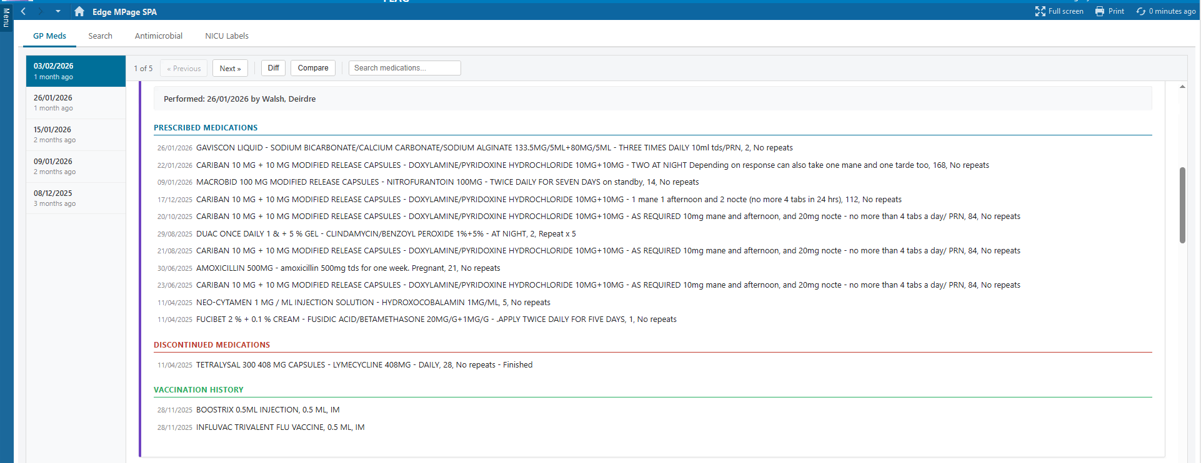

If you click on a record in the LHS bar, the message is displayed in the RHS pane but the record above it in the LHS navigation is highlighted

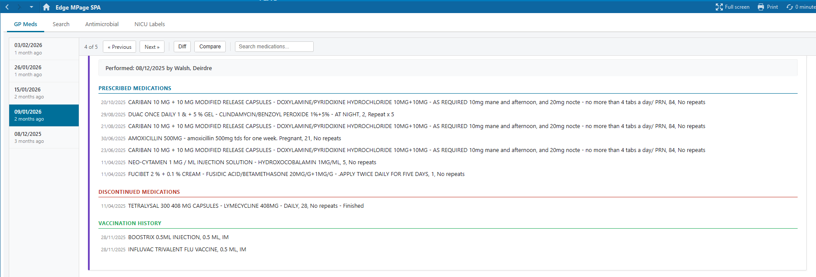

If you click Previous, it skips back two messages

